How to register an account at www.commercialagents-southeasteurope.com

What is www.commercialagents-southeasteurope.com?
The aim of the platform www.commercialagents-southeasteurope.com is to establish contacts between commercial agents and companies/principals looking for agents.
www.commercialagents-southeasteurope.com is a part of the platform come-into-contact.com and is supported by our national association and the IUCAB.Why is keeping your account information up to date important?

Why should you be registered at www.commercialagents-southeasteurope.com?
- With a current and complete account, you receive representation offers that exactly fit your profile, by email already three days before they are published online.
- When your account is up to date and complete, you maintain an overview of the market.
- And… When you choose interesting product ranges and customer groups along with your profile and products, you increase your chances of finding the right new business opportunities.

Do you have any questions?
- Send us an email by going to www.commercialagents-southeasteurope.com /kontakt.html
- or ask us if your question is not directly related to the platform.

How do I register as a commercial agent?
- There is only one requirement – agents need to have an Organization Number.
- If you are a member but do not know your organization number, please contact your association.
- To register on the platform, open this web site: www.commercialagents-southeasteurope.com/hvregister.html
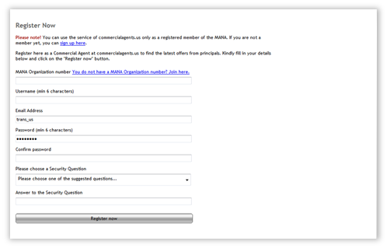
- Please make sure your password has at least six (6) characters.
- After you have entered all information, you will receive an email containing an activation link. Once you open the link and log in, your account will be activated.

Setting up your account
After your account is activated, you need to enter additional information about your field of business. This information is important as it allows the platform to send new offers by email that are of interest to you.

Email push service
Tick the box for the email push service function. You will then receive new offers three days before their online publication. Plus, you will always be informed of who in your sector is looking for new or more sales staff.
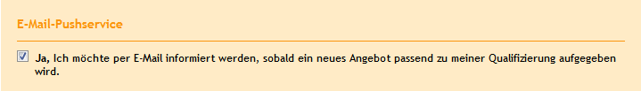
Example screenshot — actual content may look different)

Your profile
Under “My Profile” enter a description of your business, products, and services. Add important keywords. Your profile will be displayed to companies that search the agent database.
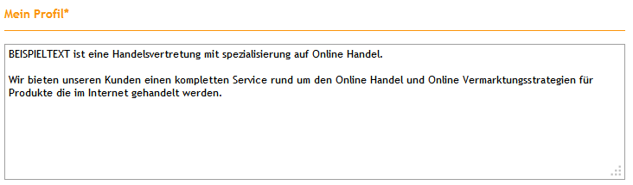
Example screenshot — actual content may look different)

Product ranges and products
Review your current product ranges/products (indicated by the red colour). To add new categories or remove existing ones, click on each item.
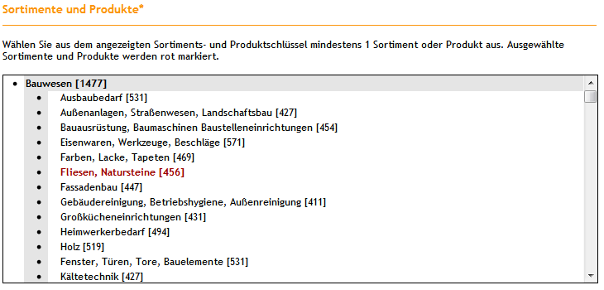
Example screenshot — actual content may look different)

Customers and buyers (industry sectors)
Review your current selected industry sectors (customers/buyers).To add new categories or remove existing ones, click on each name.
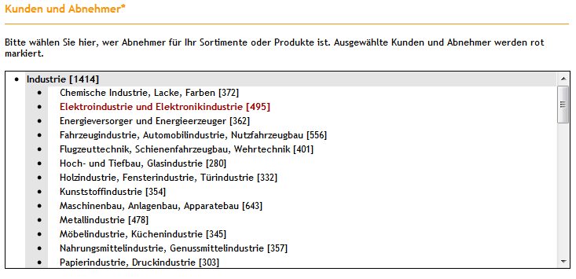
(Example screenshot — actual content may look different)

Sales regions
Review your current selected sales regions. The selection is indicated by the change of colour to red.
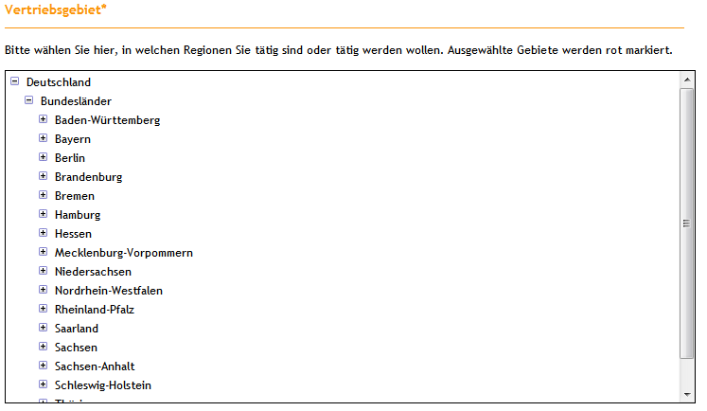
(Example screenshot — actual content may look different)

Please note: A careful choice of your product ranges and products, customers and buyers, and sales regions is crucial so you can be found when principals search the Agent Directory — and for you to receive offers via the email push service.

Logo upload
Add your logo. Your logo is shown in the overview of search results and on your detail page.

Personal details and company details
Check your personal details (salutation, title, first name, surname) and the details on your company (company name and address). Add whatever may be missing.

Contact details
Complete your contact details. This makes it easy for interested principals to get in touch with you.
Important: On www.commercialagents-southeasteurope.com you have two email addresses. In your contact details, enter the email address that should be shown in your listing in the Agent Directory. The email address can be different from the one for your account (access details). New advertisements from principals will be sent to the email address for your user account.

Access details for your user account
Your access details for your account show your username. You can change your username, user email address, and your password.
Once you have entered all required information, please click on the “Save my entry” button at the bottom of the page. If everything is entered correctly, your profile update is now complete.

Keeping your account up to date
- Keeping your account updated enhances the quality of the database and is a key factor in generating new contacts and/or business opportunities.
- It is important to update your account information when changes to the product range, customer groups, personal contact details, etc. occur.
- To update your account, visit www.commercialagents-southeasteurope.com/hvedit.html
- You can also always get to your account by clicking the Login button on the top right side of the platform web site.

